**TOPIC 2**

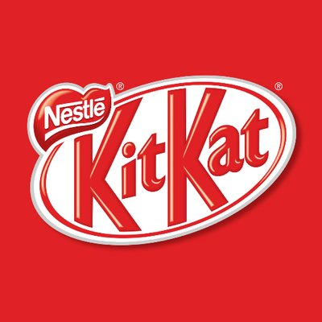

**Assignment Title:** The Social Networking Sites of Oreo and KitKat

**Student ID:** Unpublished

**Degree Programme:** BA (Hons) Business Administration

**Module Title:** Social Networking and Enterprise

**Module Code:** Unpublished

**Module Leader:** Unpublished

**Submission Date:** 21st of March 2017

**Word Count:** 1648

**Table of Contents**

**1.0 The Introduction…………………………………………….…..……..…. 3**

**2.0 The Findings and Analysis: Oreo……………...……………………......4 – 8**

**3. 0 The Findings and Analysis: KitKat………………….………………...8 – 12**

**4. 0 The Evaluation: Oreo and KitKat………….………………………...12 – 15**

**5.0 The Conclusion and Recommendation…………………..……………….16**

**6. 0 The References List……….…………………………………………...17 – 20**

The Social Networking Platforms of Oreo and KitKat

1. Introduction

In recent years, the growing popularity of social networking platforms has been seen more significant. Mintel (2016) reports that 59% of 2,000 internet users aged above 16 access social networking sites once to multiple times per day. As a result, companies now have built their online presence through social networks in an effort to reach wider audiences (Hanna, *et al.*, 2011). The aim of this report is to analyse the social networking platforms that Oreo and KitKat use to market their products. The reason for choosing these companies is because they have online presence on a variety of social media channels (see Figure 1). The products and campaigns that will be discussed are Oreo Mint, #OreoDunkSweepstakes, KitKat Chocolatery, and Personalised KitKat. There are varieties of features for businesses on social media, therefore, it is interesting to evaluate how global companies such as Oreo and KitKat use their social networking sites. This report will cover the application of theoretical evidence on online activities that Oreo and KitKat have done on their Facebook, Twitter, and YouTube. Then, evaluation on both companies’ practices to justify effective approaches will be presented. Finally, conclusion and recommendation will be provided.

Figure 1

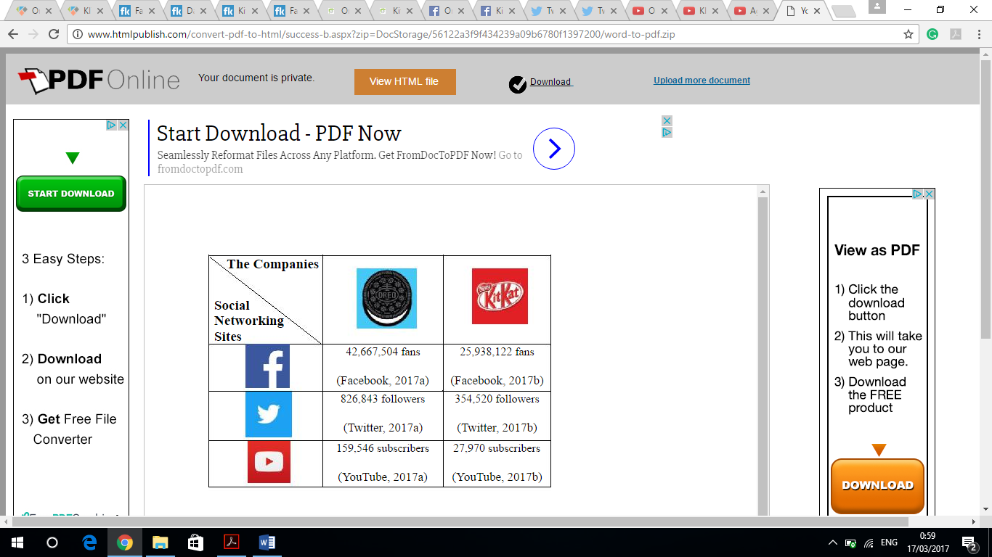

1. Oreo

Oreo Mint was interestingly being promoted on Facebook with the use of recipe video (see Figure 2). The Mint Oreo Balls recipe video was incredibly able to generate social media engagement as there are thousands of interactions under the comment section. Most importantly, there were customers who genuinely wanted to try the recipe and one of them already posted a picture of their own creation (see Figure 3). Also, Oreo has been responsive in replying its customers on Facebook which then lead to effective two-way communication (see Figure 4). Dolan *et al.* (2016) state that successful online engagement exists when companies encourage their audiences to not just passively consume content, but vigorously show behaviour in the way they comment and create new content. Indeed, customer engagement is deemed positively and directly related to satisfaction, emotional connection, and loyalty (Gummerus *et al.*, 2012). Therefore, a considerable level of engagement can occur when a company shares useful contents that are related to their products.

Figure 2

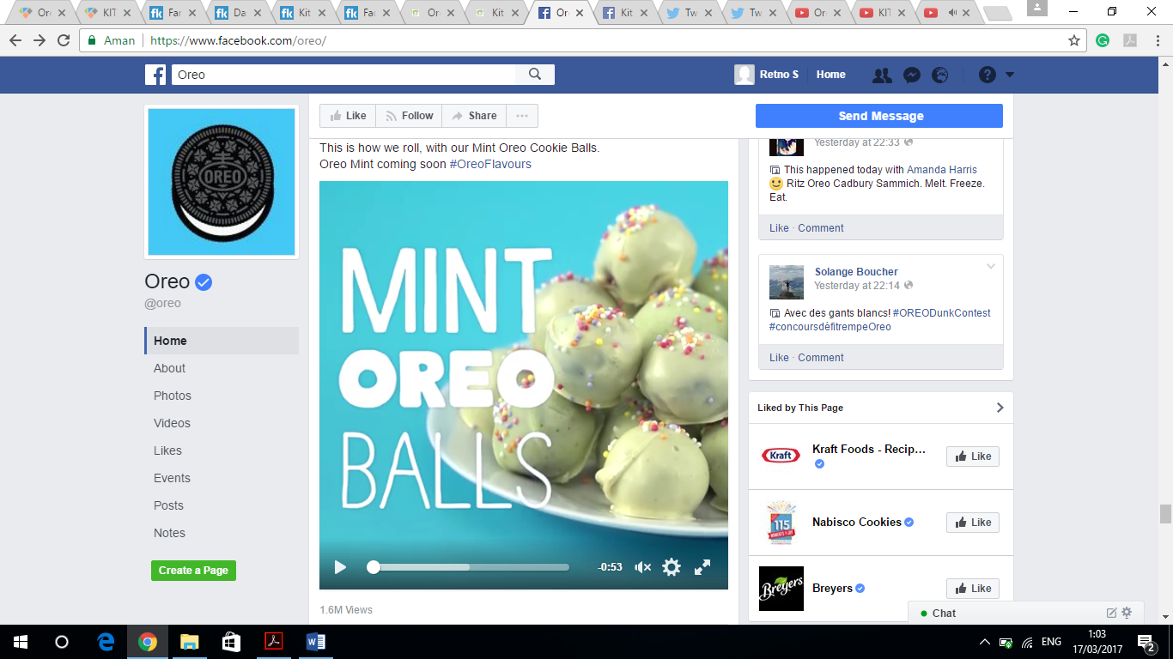 (Facebook, 2017c)

Figure 3

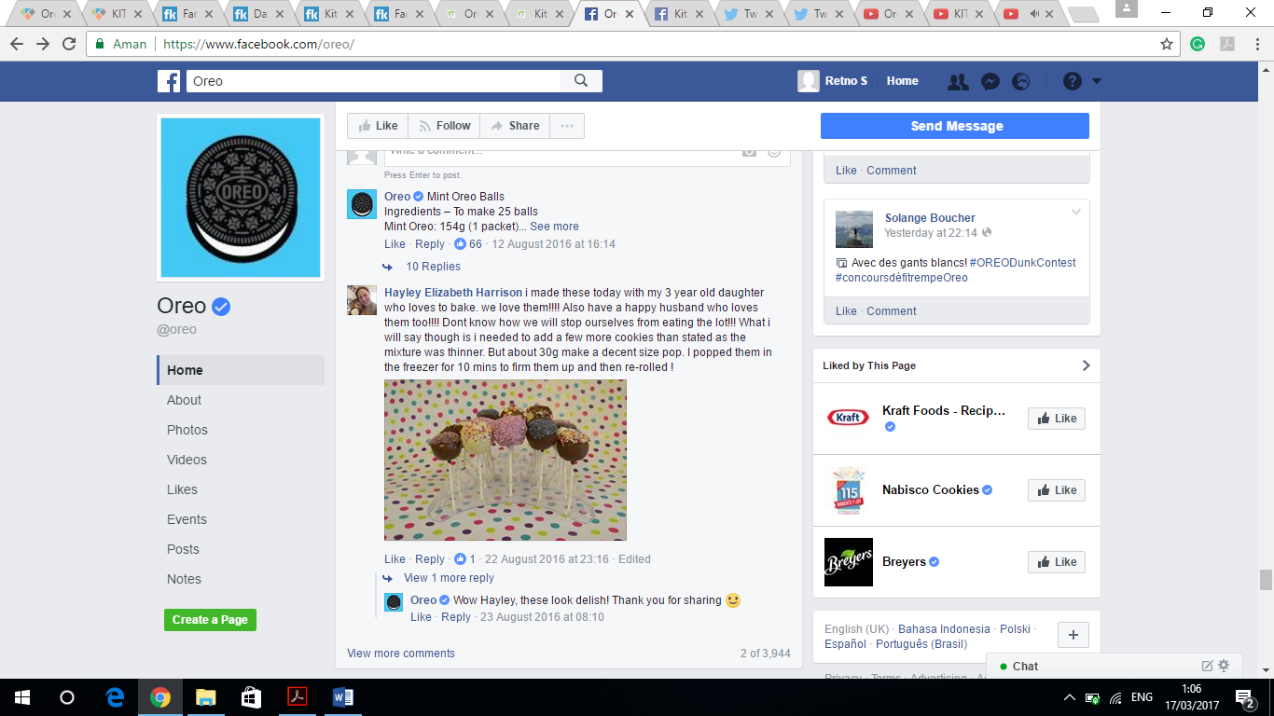 (Facebook, 2017d)

Figure 4

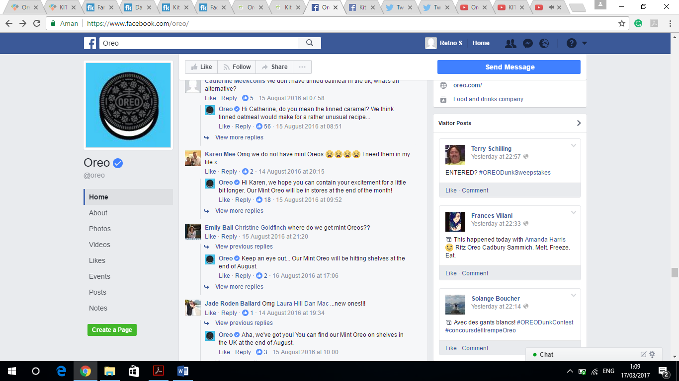 (Facebook, 2017e)

Moreover, Oreo endorses celebrities for its recent campaign in the US called #OreoDunkSweepstakes on Twitter (see Figure 5). Karasiewicz and Kowalczuk (2014) emphasise that the use of celebrity endorsement could entice customers’ attention and strengthen messages in an advertisement. For example, Christina Aguilera has just recently posted a video of her collaboration with Oreo and it results in numerous responses from her followers (see Figure 6). Customers trust in the celebrities they admire and accordingly favour the brands that the endorser promotes (Davies and Slater, 2015). Additionally, #OreoDunkSweepstakes campaign has begun a week after Oreo Thins was launched which could be a motive of creating brand awareness on the new product. Utilisation of unique marketing campaign while advertising a product can lead to greater brand awareness and recall at the time of buying decisions (Roy and Gupta, 2015). Therefore, an innovative online campaign can stand out from the crowd as it induces electronic word of mouth, which then raises customer awareness of a brand and its product.

Figure 5

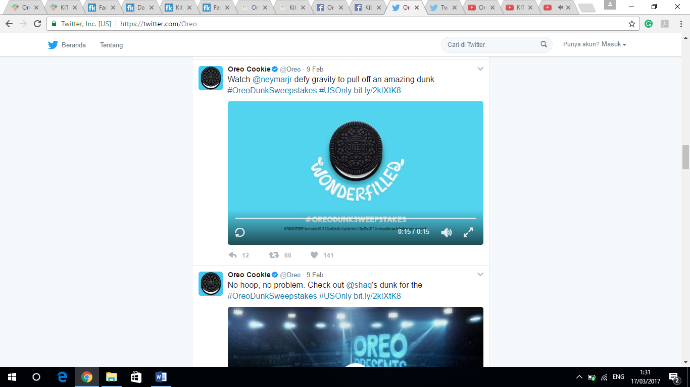 (Twitter, 2017c)

Figure 6

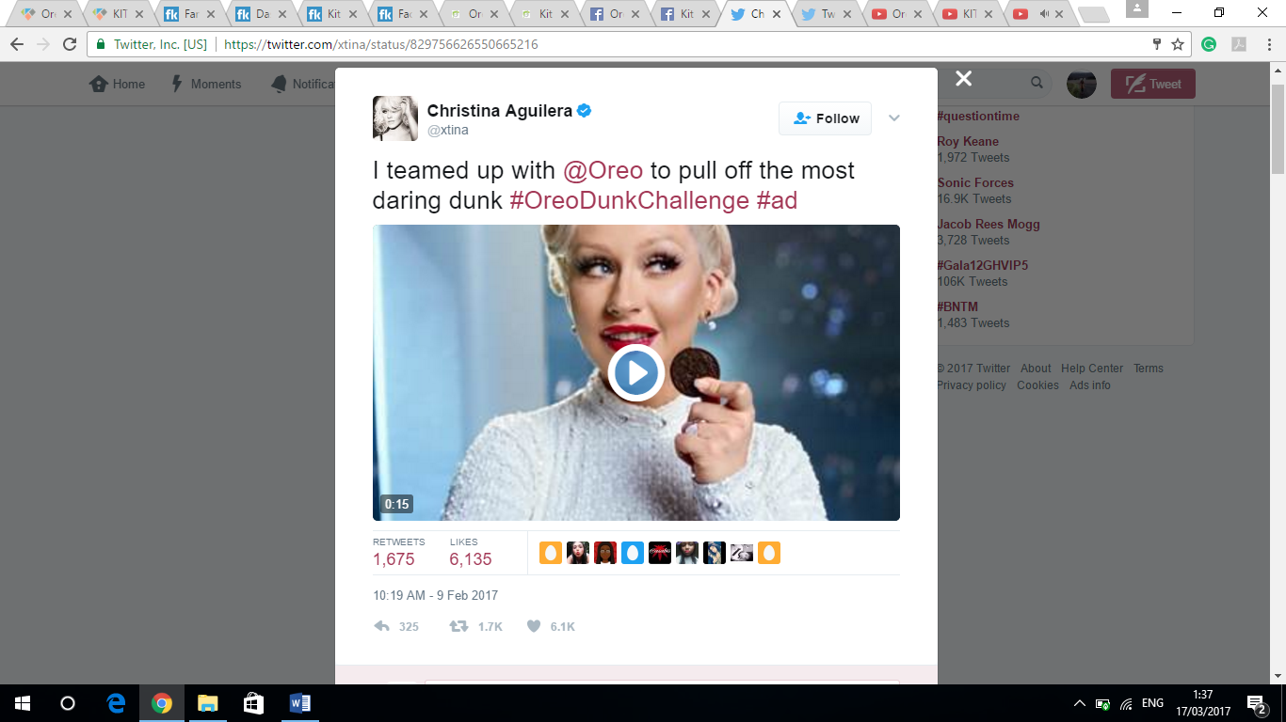 (Twitter, 2017d)

Furthermore, Oreo has uploaded multi languages videos for its #OreoDunkSweepstakes campaign on YouTube. It could be argued that Oreo aims to reach larger audiences by thinking globally and acting locally. Fastoso and Whitelock (2012) refer this approach as international marketing where companies reconsider their advertising strategies to suit with various sources of market growth and opportunity abroad. Specifically, Oreo has YouTube channels for each of its operating countries which mostly use those countries’ national languages (see Figure 7). Likewise, Oreo has featured paid advertising on YouTube which works on a pay-per-click (PPC) basis. PPC means that advertisements will be appeared at the minute someone is looking for keyword that matches particular keywords associated with a firm (Alkarablieh and Khraim, 2015). It is considered as a cost-effective means of online marketing, because the firm only pays when someone clicks the link presented within their advertisements. Hence, YouTube potentially assists companies in reaching more relevant audiences.

Figure 7

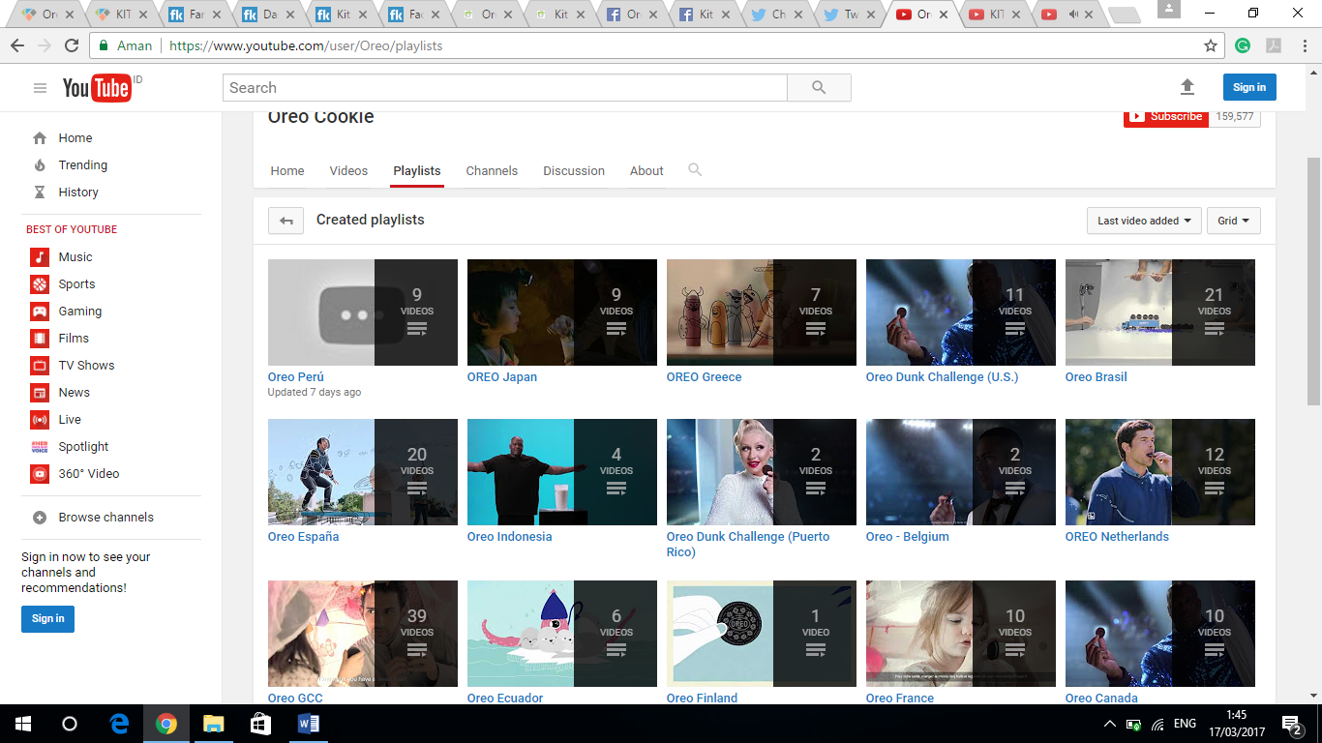

(YouTube, 2017c)

1. KitKat

KitKat was undertaking a live streaming video when it launched its Chocolatory products variance on Facebook (see Figure 8). Facebook Live feature has been predicted as a key that directs traffic to an official Facebook page of any company (Stangel, 2016). The higher traffic to the company Facebook page, the higher the brand awareness and the more users engage in convincing other users to evaluate the suggested brand (Luo and Zhang, 2013). It could be contended that social media traffic can lead to different levels of engagement among users towards a brand. The vast majority of interactions on KitKat live streaming came from the users who fall under the Critics group (see Figure 9). The Critics are a group of customers who engage by sharing their thoughts, in a manner where their views could be used to improve business performance (Li and Bernoff, 2011). It is crucial for companies to appropriately source where their traffic should come from, thus obtaining targeted group of customers.

Figure 8

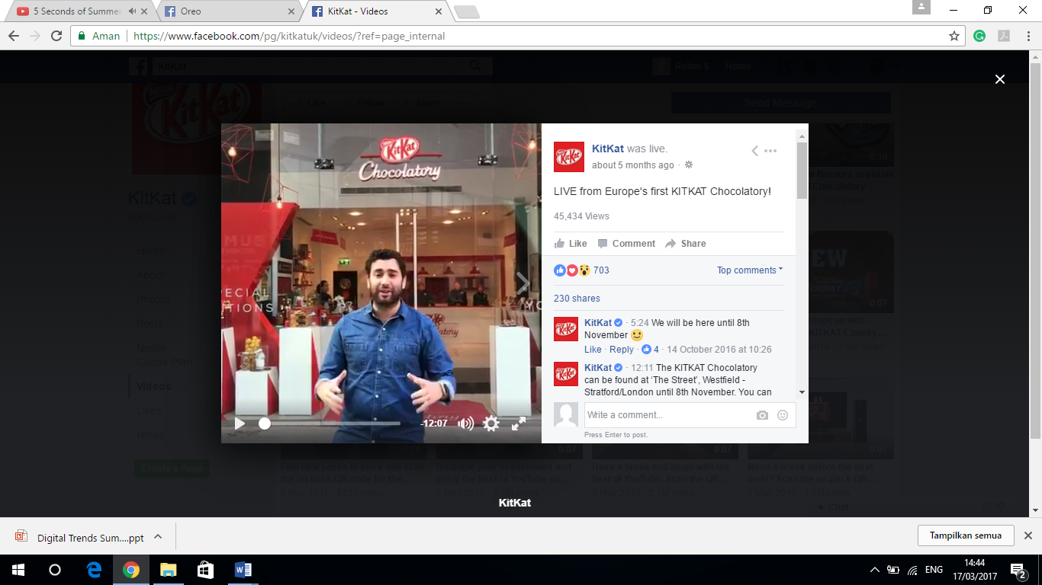

(Facebook, 2017f)

Figure 9

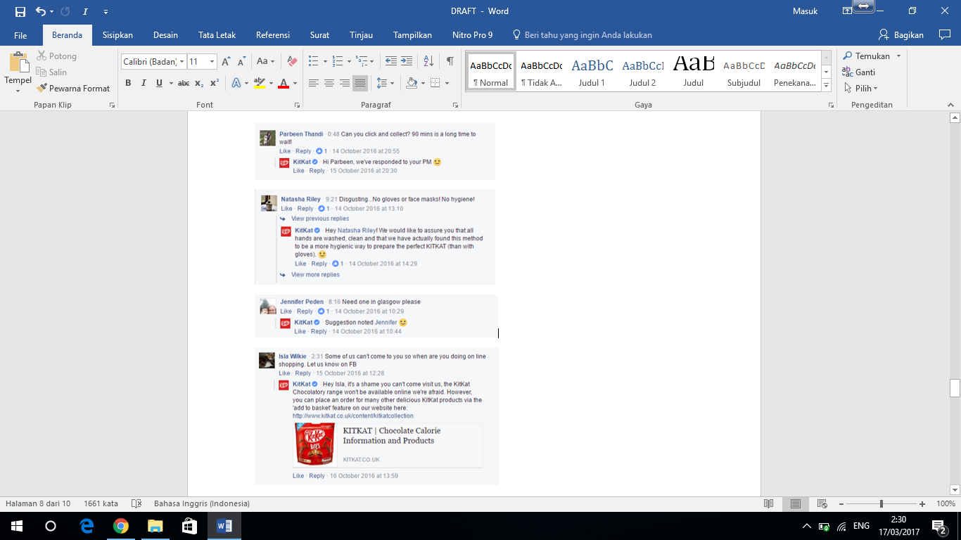(Facebook, 2017g)

Moreover, KitKat has conducted a daily contest with a chance to win its personalised product for customers who purchase a promotional pack (see Figure 10). Barker *et al.* (2013) affirm that online contest could be a great approach to build relationship with new customers when correctly implemented. It could be said that online contest is a post purchase strategy where a company keeps get in touch with its customers with a purpose to influence them for repurchasing. Furthermore, winners can post a picture of their personalised package on Twitter with #mybreak (see Figure 11). This method reflects on how KitKat customers, who are mainly millennials, connect with the brand. Millenials tend to post their consumption activities, interests and aspiration on social media frequently (Bolton *et al.*, 2013). As a result, most millennials take action on behalf of brands and communicate brand preferences in their social groups online.

Figure 10

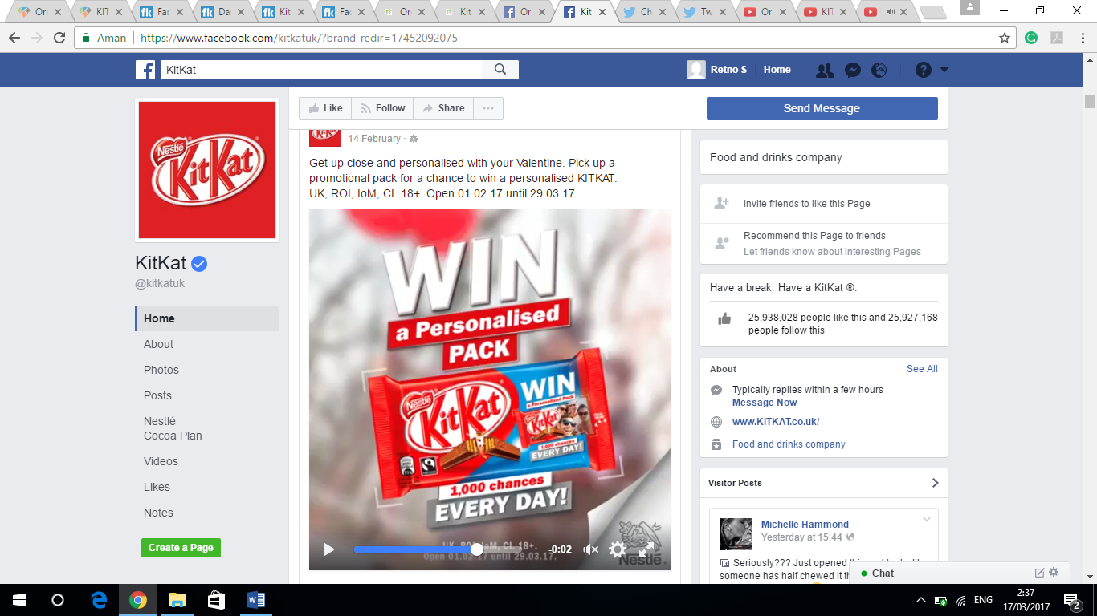(Facebook, 2017h)

Figure 11

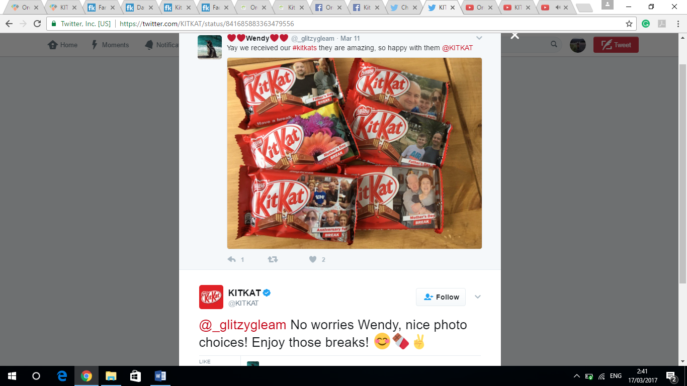(Twitter, 2017e)

In addition, the use of #mybreak is not merely for the winners of personalised KitKat. Customers are encouraged to share their experience with KitKat using #mybreak. Schneider (2015) suggests that hashtags are vital for companies that are involved in social media as it enables them to track related conversations occurring worldwide. In KitKat’s case, the slogan of “Have a Break Have a KitKat” is directly linked to #mybreak. Customers share their experience on how to enjoy their break times with KitKat using many creative ways (see Figure 12). The conversations around #mybreak has happened on a day-to-day basis, and KitKat builds the personal connection by responding each and every post daily. Thus, iconic hashtags can be very powerful for companies to initiate interactions with their fans on social media.

Figure 13

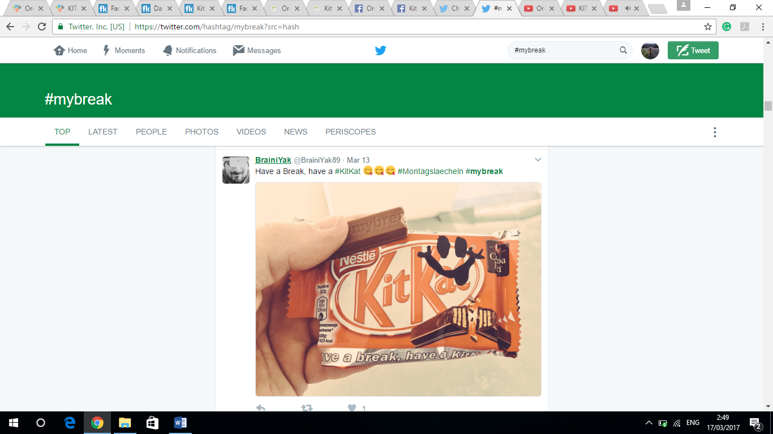 (Twitter, 2017f)

1. Evaluation

Based on the analyses of the main findings, it could be evaluated that Oreo and KitKat have different approaches in using their social media platforms. First, Oreo has not only shared posts that have diverse meanings – entertaining, challenging, and informative – for every content on its Facebook page, but also are still relevant to its products. Conversely, KitKat has shared posts that are less creative in which those posts contain nearly similar contents on its Facebook page. Furthermore, Oreo shares posts more frequently than KitKat does (see Figure 14). These could be reasons why Oreo has achieved a much higher level of engagement compared to KitKat on Facebook (see Figure 15).

Figure 14

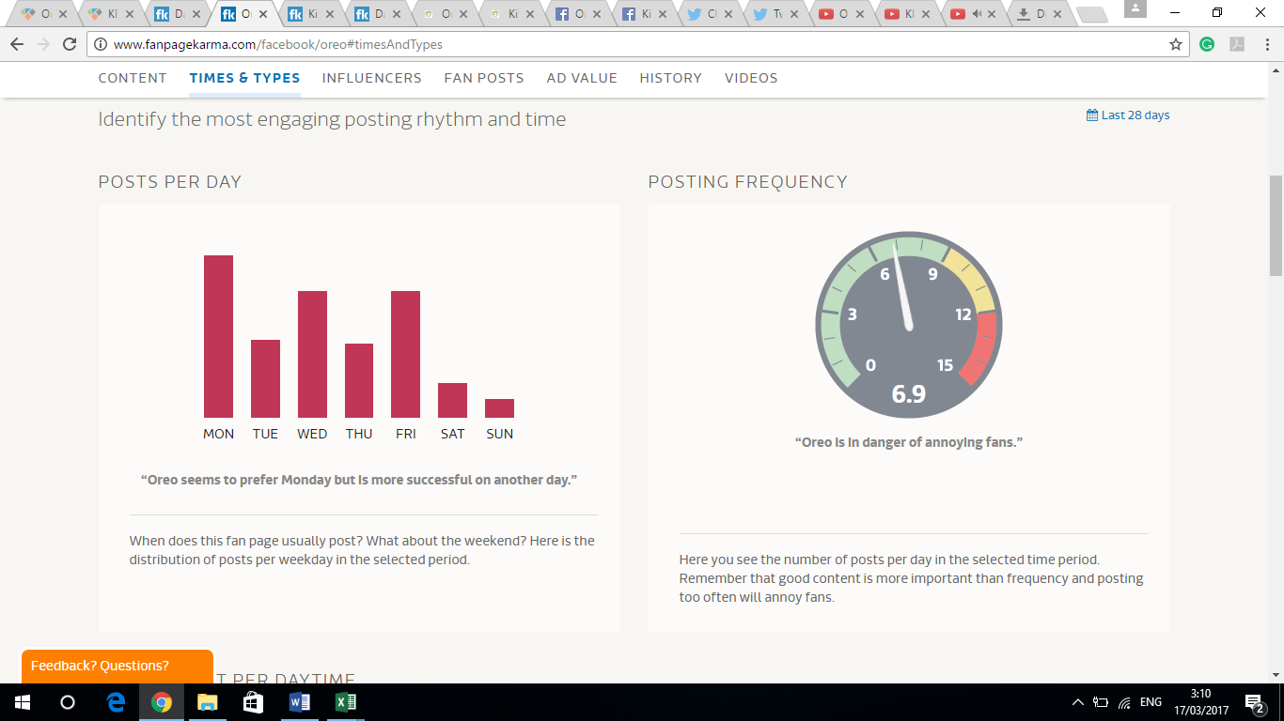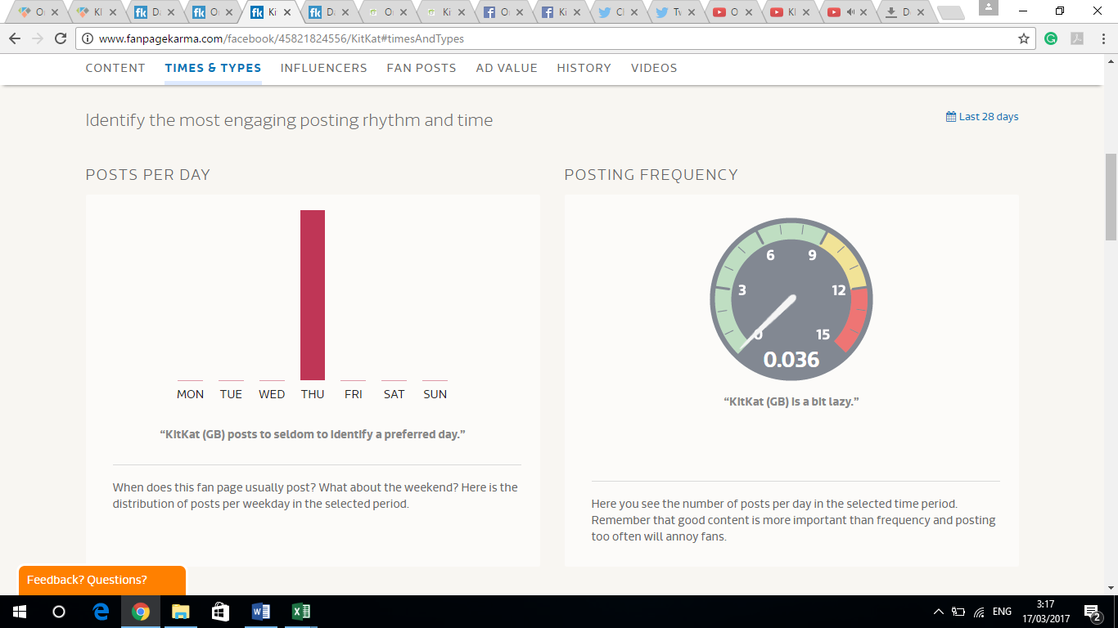

(Fanpage Karma, 2017a)

Figure 15

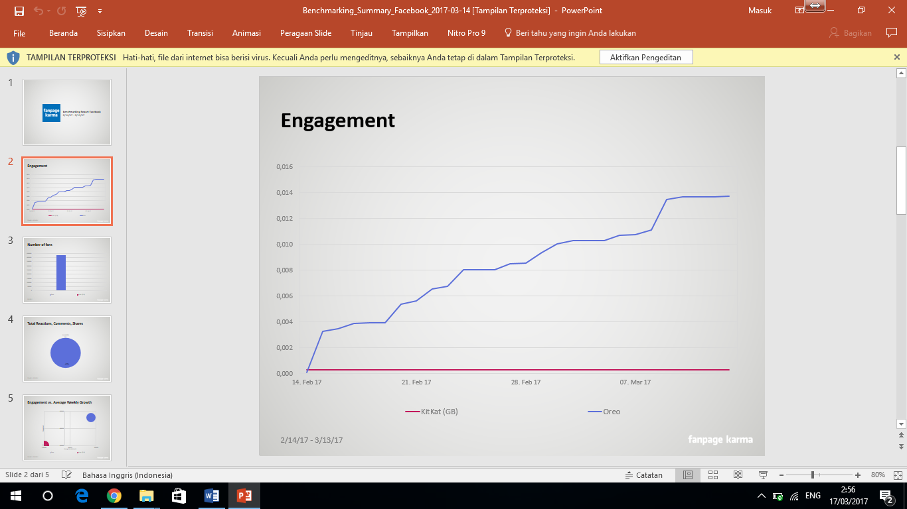

(Fanpage Karma, 2017b)

However, KitKat has built more conversations with its followers on Twitter which could be because it uses hashtag – #mybreak – which can be easily related to daily life activities. Klear (2017a) reports that 71% of users’ tweets have been replied by KitKat. Twitter is seen as the most influential social media channel for KitKat (see Figure 16). Thus, KitKat has greater page performance rate, even though it has fewer Twitter followers than Oreo has (see Figure 17).

Figure 16

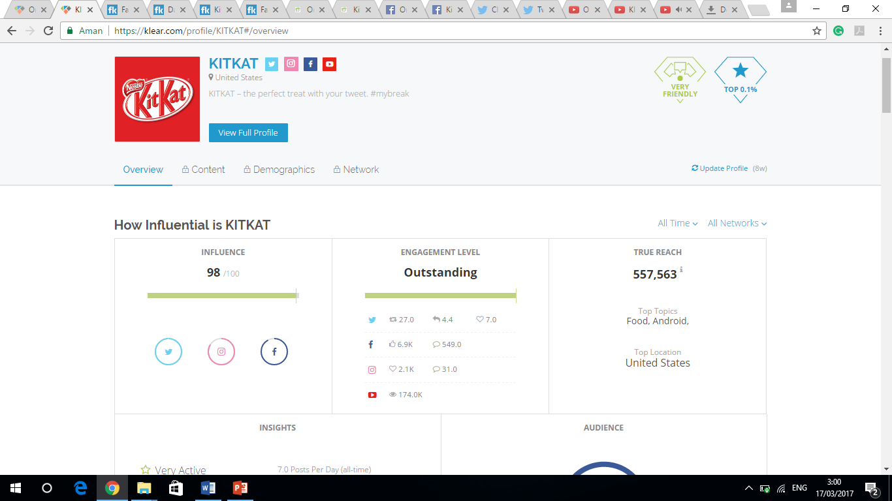(Klear, 2017b)

Figure 17

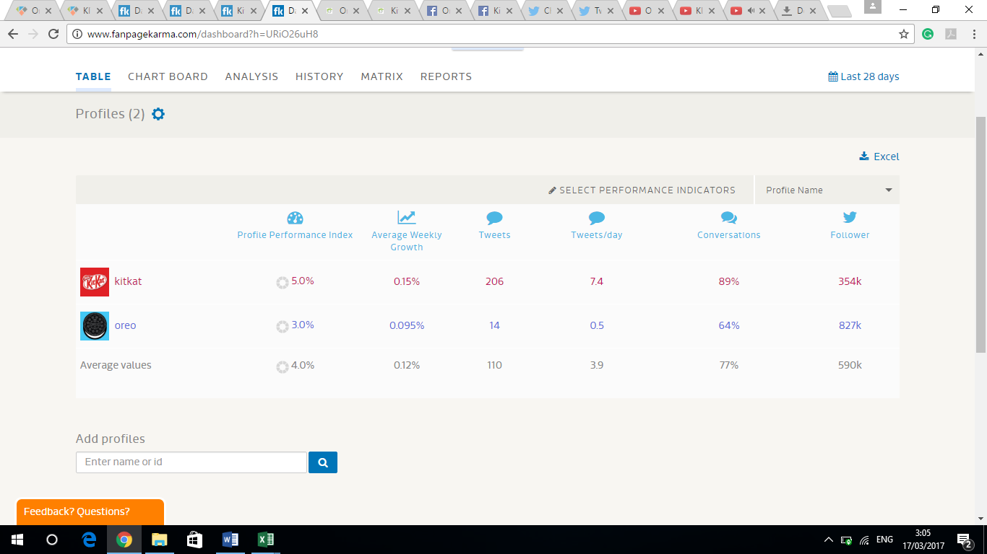

(Fanpage Karma, 2017c)

Notwithstanding, both Oreo and KitKat still have relatively low social media engagement rate (see Figure 18). Phillips (2013) states that one of the several reasons for low engagement is because lack of segmentation. The average age of Oreo’s audiences is around 24 years old (Klear, 2017c). In fact, Oreo does not in fact focus on producing contents that suit best with this demographic segmentation. For instance, Oreo has uploaded more cartoon videos for children rather than featuring young people in their advertising videos. The low engagement rate of KitKat could be because the timing of sharing which is not appropriate (see Figure 19).

Figure 18

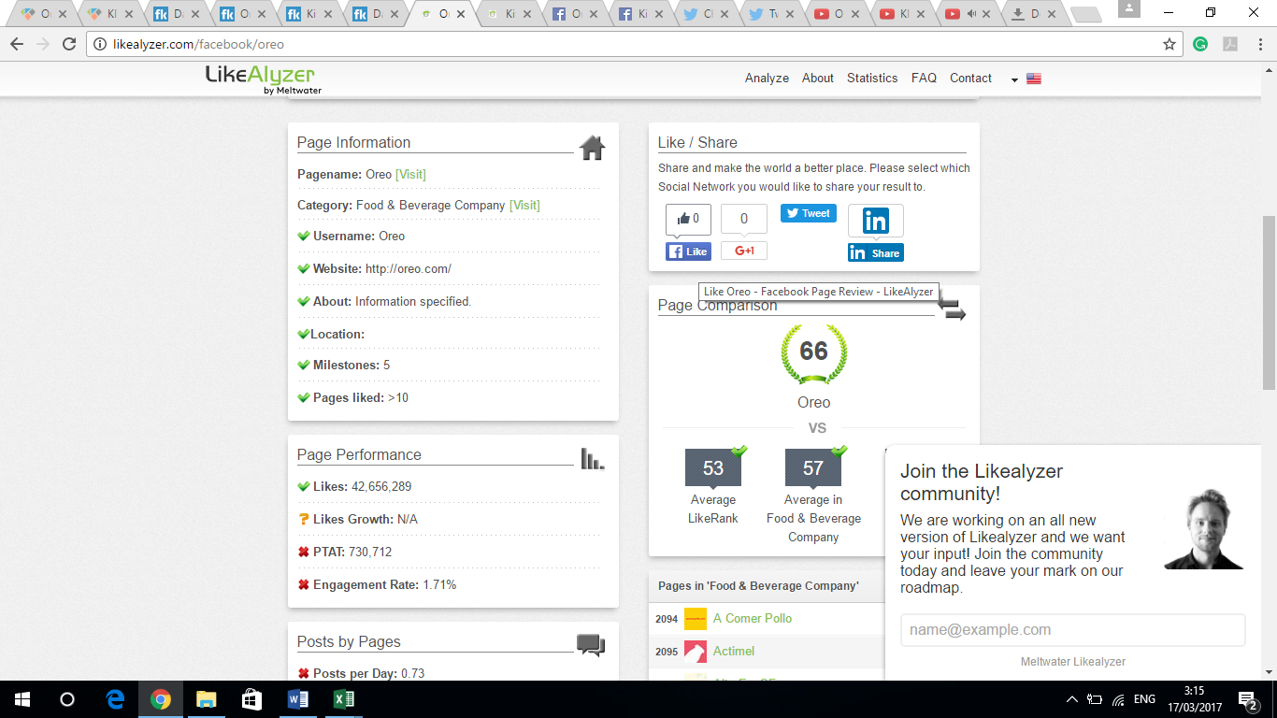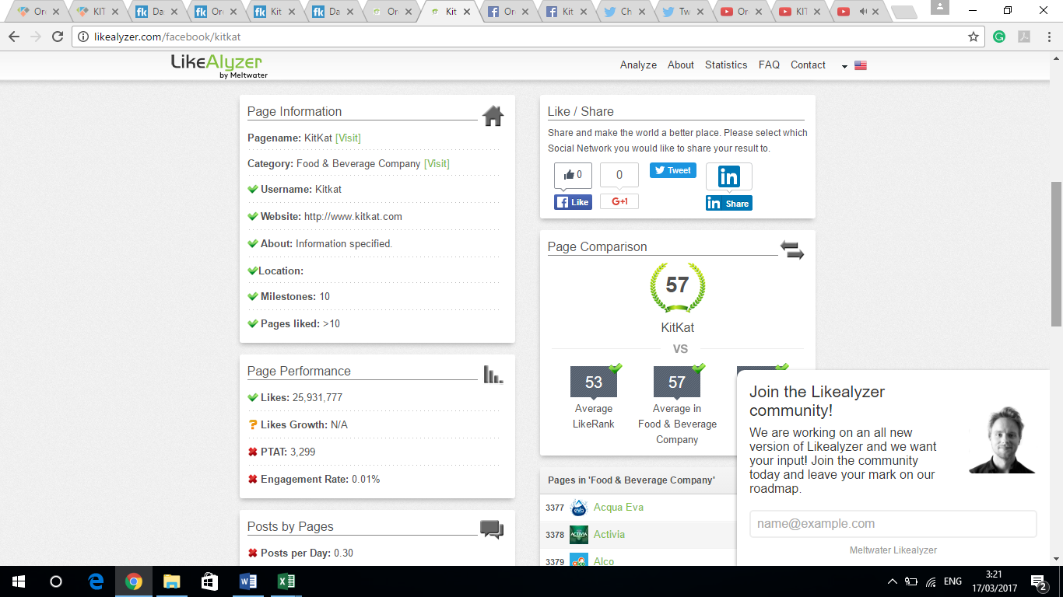 (LikeAlyzer, 2017a)

Figure 19

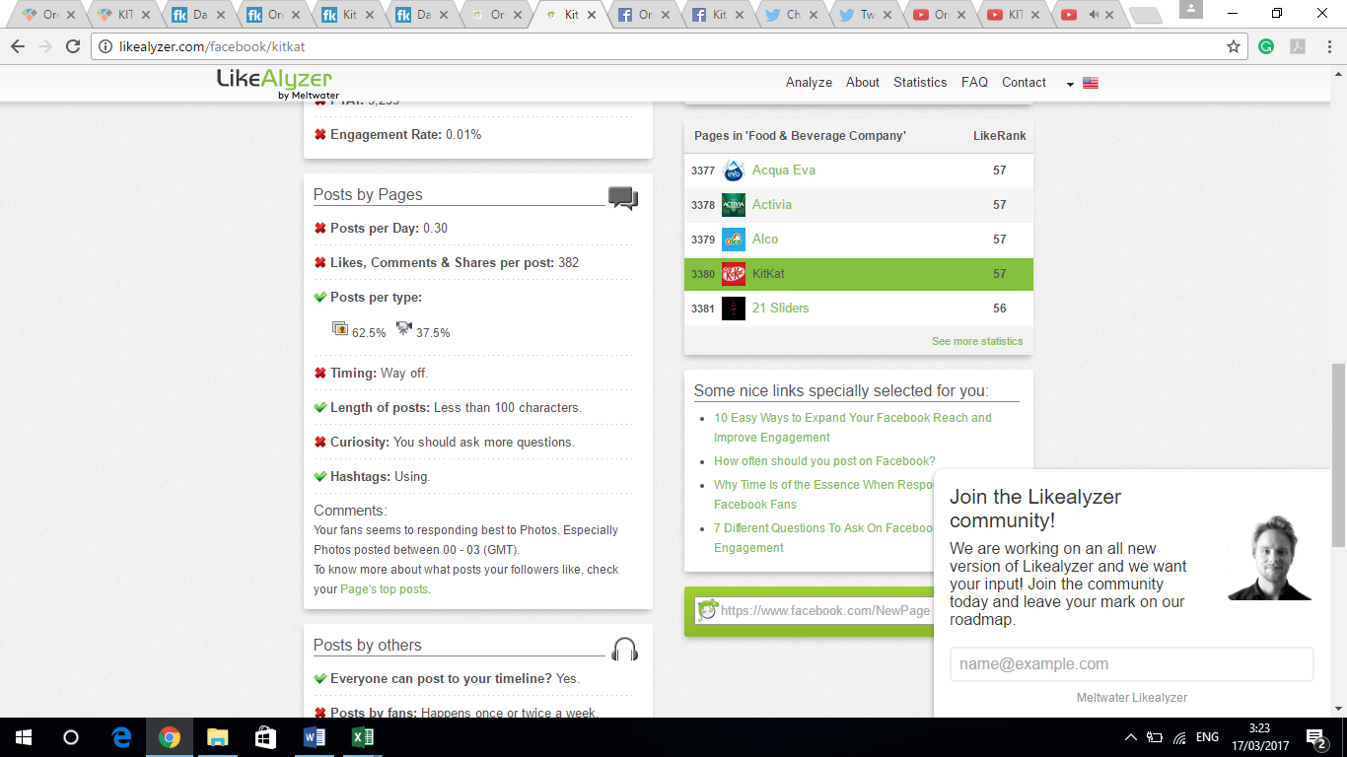 (LikeAlyzer, 2017b)

1. Conclusions and Recommendation

In conclusion, social networking platforms have improved the way Oreo and KitKat market their products. Essentially, they have been employed in helping both companies to reach wider customers. Comparatively, Oreo has used a better approach in promoting its products compared to KitKat. Oreo has invited a wide audience to participate in its #OreoDunkSweepstakes campaign, in which this campaign does not require participants to purchase Oreo’s product. This campaign has gone viral since the day of its launch as it is featured with famous celebrities, thus creating more brand awareness. Also, great usage of online campaign can be an effective approach for a product launch. Wohl (2017) reports that the sales of new Oreo Thins has gone up almost 131% to $125.2 million.

Companies must always be prepared to innovate and upgrade their approach towards social media in order to maintain their effective online activities. It is recommended that Oreo and KitKat should make use of Snapchat to drive better engagement with its audiences who are mostly of the young generations. Patel (2016) states that 58% of college students use Snapchat every day. Snapchat is a best possible opportunity to begin teasing out videos or pictures of new products. Videos or pictures that last for a few second leads to curiosity of users. Therefore, companies could attract a fair amount of word of mouth to spread around their new offerings.

1. References List

Alkarablieh, A. A. and Khraim, H. S. (2015) ‘The Effect of Using Pay Per Click Advertisement on Online Advertisement Effectiveness and Attracting Customers in E-marketing Companies in Jordan’. *International Journal of Marketing Studies.* 7 (1) pp. 180 – 189 [Online] Available at: <http://dx.doi.org/10.5539/ijms.v7n1p180> [Accessed: 5 March, 2017].

Barker, M. S., Barker, D. I., Bormann, N. F. and Neher, K. E. (2013) *Social Media Marketing: A Strategic Approach.* 1st edn.South-Western: Cengange Learning. [Online] Available at: <https://books.google.co.uk/books?id=kdgKAAAAQBAJ&printsec=frontcover&hl=id&source=gbs_ge_summary_r&cad=0#v=onepage&q&f=false> [Accessed: 12 Mrach, 2017].

Bolton, R. N., Parasuraman, A., Hoefnagels, A., Migchels, N., Kabadayi, S., Gruber, T., Loureiro, Y. K. and Solnet, D. (2013) ‘Understanding Generation Y and their use of social media: a review and research agenda’. *Journal of Service Management.* 24 (3) pp. 245 – 267 [Online] Available at: <http://www.emeraldinsight.com/doi/full/10.1108/09564231311326987> [Accessed: 11 March, 2017].

Davies, S. and Slater, S. (2015) ‘Unpacking celebrity brands through unpaid market communications’. *Journal of Marketing Management.* 31 (5 – 6) pp. 665 – 684 [Online] Available at: <http://dx.doi.org/10.1080/0267257X.2014.1000941> [Accessed: 10 March, 2017].

Dolan, R., Conduit, J., Fahy, J. and Goodman, S. (2016) ‘Social media engagement behaviour: a uses and gratifications perspective’. *Journal of Strategic Marketing.* 24 (3 – 4) pp. 261 – 277 [Online] Available at: <http://dx.doi.org/10.1080/0965254X.2015.1095222> [Accessed: 1 March, 2017].

Facebook (2017a) *Oreo Homepage.* Available at: <https://www.facebook.com/oreo/> [Accessed: 20 February, 2017].

Facebook (2017b) *KitKat Homepage.* Available at: <https://www.facebook.com/kitkatuk/?brand_redir=17452092075> [Accessed: 20 February, 2017].

Facebook (2017c) *Oreo Posts.* Available at: <https://www.facebook.com/pg/oreo/posts/?ref=page_internal> [Accessed: 20 February, 2017].

Facebook (2017d) *Mint Oreo Balls Comments.* Available at: <https://www.facebook.com/pg/oreo/posts/?ref=page_internal> [Accessed: 20 February, 2017].

Facebook (2017e) *Mint Oreo Balls Comments.* Available at: <https://www.facebook.com/pg/oreo/posts/?ref=page_internal> [Accessed: 20 February, 2017].

Facebook (2017f) *KitKat Videos.* Available at: <https://www.facebook.com/pg/kitkatuk/videos/?ref=page_internal> [Accessed: 21 February, 2017].

Facebook (2017g) *KitKat Chocolatory Live Comments.* Available at: <https://www.facebook.com/pg/kitkatuk/videos/?ref=page_internal> [Accessed: 21 February, 2017].

Facebook (2017h) *KitKat Posts.* Available at: <https://www.facebook.com/pg/kitkatuk/posts/?ref=page_internal> [Accessed: 21 February, 2017].

Fanpage Karma (2017a) *Oreo and KitKat Analysis.* Available at: <http://www.fanpagekarma.com/dashboard?h=UWH8CjUv8#analysen> [Accessed: 14 March, 2017].

Fanpage Karma (2017b) *Oreo and KitKat Chart Board.* Available at: <http://www.fanpagekarma.com/dashboard?h=UWH8CjUv8#chartboard> [Accessed: 14 March, 2017].

Fanpage Karma (2017c) *Oreo and KitKat Table.* Available at: <http://www.fanpagekarma.com/dashboard?h=UWH8CjUv8#tabelle> [Accessed: 14 March, 2017].

Fastoso, F. and Whitelock, J. (2012) ‘The implementation of international advertising strategies: an exploratory study in Latin America’. *International Marketing Review.* 29 (3) pp. 313 – 335 [Online] Available at: <http://dx.doi.org/10.1108/02651331211229787> [Accessed: 11 March, 2017].

Gummerus, J., Liljander, V., Weman, E. and Pihlstrom, M. (2012) ‘Customer engagement in a Facebook brand community’. *Management Research Review.* 35 (9) pp. 857 – 877 [Online] Available at: <http://dx.doi.org/10.1108/01409171211256578> [Accessed: 7 March, 2017].

Hanna, R., Rohm, A. and Crittenden, V. L. (2011) ‘We’re all connected: The power of the social media ecosystem’. *Business Horizons.* 54 (3) pp. 265 – 273 [Online] Available at: <http://dx.doi.org/10.1016/j.bushor.2011.01.007> [Accessed: 2 March, 2017].

Karasiewicz, G. and Kowalczuk, M. (2014) ‘Effect of Celebrity Endorsement in Advertising Activities by Product Type’. *International Journal of Management and Economics.* 44 (1) pp. 74 – 91 [Online] Available at: <https://doi.org/10.1515/ijme-2015-0010> [Accessed: 1 March, 2017].

Klear (2017a) *KitKat Insights.* Available at: <https://klear.com/profile/KITKAT#/overview> [Accessed: 15 March, 2017].

Klear (2017b) *KitKat Influence.* Available at: <https://klear.com/profile/KITKAT#/overview> [Accessed: 15March, 2017].

Klear (2017c) *KitKat’s Audience Demographics.* Available at: <https://klear.com/profile/KITKAT#/overview> [Accessed: 15 March, 2017].

Li, C. and Bernoff, J. (2011) *Groundswell, Expanded and Revised Edition: Winning in a World Transformed by Social Technologies.* 1st edn. Boston: Harvard Business School Publishing [Online] Available at: <https://books.google.co.uk/books?id=FrB8QCQojyYC&printsec=frontcover&hl=id&source=gbs_ge_summary_r&cad=0#v=onepage&q=critics&f=false> [Accessed: 5 March, 2017].

LikeAlyzer (2017a) *Page Information and Page Performance.* Available at: <http://likealyzer.com/facebook/oreo> [Accessed: 18 March, 2017].

LikeAlyzer (2017b) *Posts by Pages.* Available at: <http://likealyzer.com/facebook/kitkat> [Accessed: 18 March, 2017].

Luo, X. and Zhang, J. (2013) ‘How Do Consumer Buzz and Traffic in Social Media Marketing Predict the Value of the Firm?’ *Journal of Management Information Systems.* 30 (2) pp. 213 – 238. DOI: 10.2753/MIS0742-1222300208

Mintel (2016) *Digital Trends Summer – UK – July 2016.* Mintel. Available at: <http://academic.mintel.com/display/748654/> [Accessed: 2 March, 2017].

Patel, S. (2016) *The Quick Guide to Using Snapchat for Business in 2016.* Entrepreneur. Available at: <https://www.entrepreneur.com/article/270663> [Accessed: 11 March, 2017].

Phillips, M. (2013) *Why your engagement rate is low and how you can fix it.* Econsultancy. Available at: <https://econsultancy.com/blog/62694-why-your-engagement-rate-is-low-and-how-you-can-fix-it/> [Accessed: 6 March, 2017].

Roy, A. and Gupta, R. (2015) ‘Media Innovations and its Impact on Brand awareness & Consideration’. *Journal of Business and Management.* 17 (11) pp. 132 – 136 [Online] Available at: <http://iosrjournals.org/iosr-jbm/papers/Vol17-issue12/Version-2/R017122132136.pdf> [Accessed: 8 March, 2017].

Stangel, L. (2016) *Here's ​Facebook’s five-year mobile video prediction.* Business Journal. Available at: <http://www.bizjournals.com/sanjose/news/2016/10/26/heres-facebook-s-five-year-mobile-video-prediction.html> [Accessed: 4 March, 2017].

Twitter (2017a) *Oreo Cookie @Oreo.* Available at: <https://twitter.com/oreo> [Accessed: 22 February, 2017].

Twitter (2017b) *KITKAT @KITKAT*. Available at: <https://twitter.com/KITKAT> [Accessed: 22 February, 2017].

Twitter (2017c) *Oreo Tweet.* Available at: <https://twitter.com/oreo> [Accessed: 22 February, 2017].

Twitter (2017d) *Christina Aguilera Tweet.* Available at: <https://twitter.com/xtina> [Accessed: 23 February, 2017].

Twitter (2017e) *KitKat Tweet & Replies.* Available at: <https://twitter.com/KITKAT/with_replies> [Accessed: 23 February, 2017].

Twitter (2017f) *KitKat #mybreak.* Available at: <https://twitter.com/hashtag/mybreak?src=hash> [Accessed: 23 February, 2017].

Wohl, J. (2017) *Oreo Enlists Celebs to Demonstrate the Perfect Dunk in Latest Global Push.* Advertising Age. Available at: <http://adage.com/article/cmo-strategy/oreo/307896/> [Accessed: 5 March, 2017].

YouTube (2017a) *Oreo Cookie Home.* Available at: <https://www.youtube.com/user/Oreo/featured> [Accessed: 24 February, 2017].

YouTube (2017b) *KitKat Home.* Available at: <https://www.youtube.com/user/kitkat> [Accessed: 24 February, 2017].

YouTube (2017c) *Oreo Playlists.* Available at: <https://www.youtube.com/user/Oreo/playlists> [Accessed: 24 February, 2017].